SQL LOAN APPLICATIONS QUERIES AND RESULTS
- Customer Demographics Overview
SELECT
AVG(Age) AS avg_age,
MIN(Age) AS min_age,
MAX(Age) AS max_age,
COUNT(*) AS total_customers
FROM loan_applications;
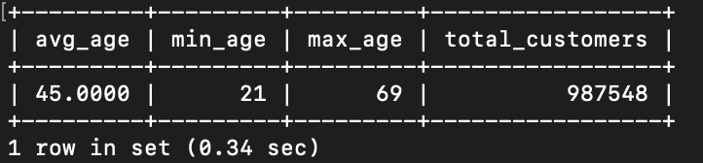
- Income Distribution by Education Level
Income Distribution by Education Level
SELECT
Education_Level,
AVG(Income) AS avg_income,
COUNT(*) AS total_applicants
FROM loan_applications
GROUP BY Education_Level
ORDER BY avg_income DESC;
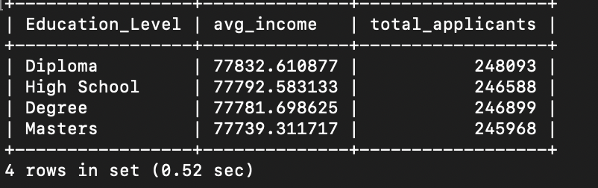
- Credit Score Analysis by Region
SELECT
Region,
AVG(Credit_Score) AS avg_credit_score,
MIN(Credit_Score) AS min_score,
MAX(Credit_Score) AS max_score
FROM loan_applications
GROUP BY Region;
- Loan Amount vs Term Correlation
SELECT
Loan_Term_Months,
AVG(Loan_Amount) AS avg_loan_amount
FROM loan_applications
GROUP BY Loan_Term_Months
ORDER BY Loan_Term_Months;
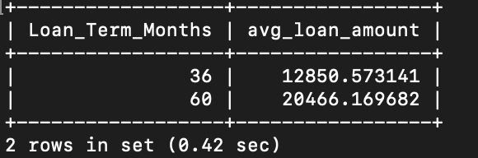
- Default Rate by Credit Score Range
SELECT
CASE
WHEN Credit_Score < 500 THEN 'Poor'
WHEN Credit_Score BETWEEN 500 AND 650 THEN 'Fair'
WHEN Credit_Score BETWEEN 651 AND 750 THEN 'Good'
ELSE 'Excellent'
END AS credit_band,
COUNT(*) AS total_applicants,
SUM(Defaulted) AS total_defaults,
ROUND(SUM(Defaulted) * 100.0 / COUNT(*), 2) AS default_rate_percent
FROM loan_applications
GROUP BY credit_band;
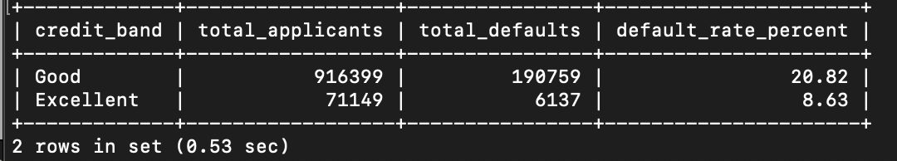
- Total loans Approved vs rejected
SELECT
Approval_Status,
COUNT(*) AS total_applications
FROM loan_applications
GROUP BY Approval_Status;
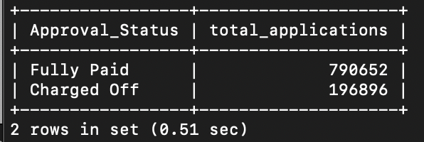\
- Loan purpose Popularity
SELECT
Loan_Purpose,
COUNT(*) AS total_requests
FROM loan_applications
GROUP BY Loan_Purpose
ORDER BY total_requests DESC;
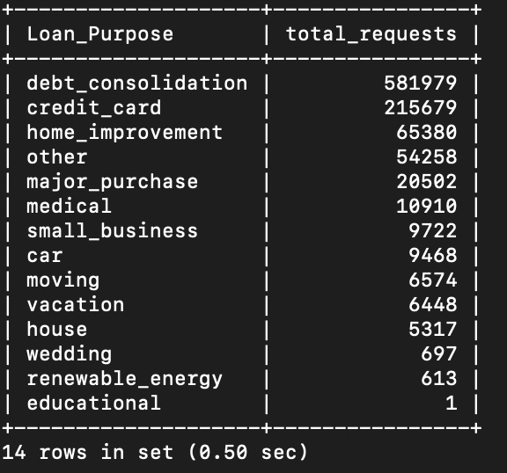
- Regional Loan demand
SELECT
Region,
COUNT(*) AS total_applications,
SUM(Loan_Amount) AS total_loan_value
FROM loan_applications
GROUP BY Region
ORDER BY total_loan_value DESC;
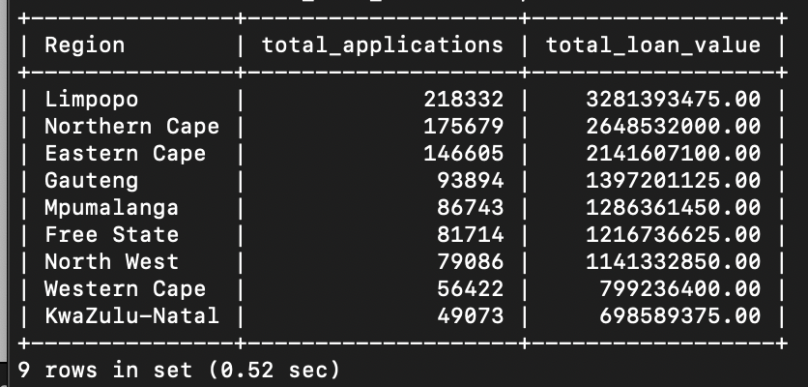

- Customer Segmentation by Age and Marital Status
SELECT
Marital_Status,
CASE
WHEN Age < 30 THEN 'Under 30'
WHEN Age BETWEEN 30 AND 50 THEN '30-50'
ELSE 'Over 50'
END AS age_group,
COUNT(*) AS total_customers
FROM loan_applications
GROUP BY Marital_Status, age_group
ORDER BY total_customers DESC;
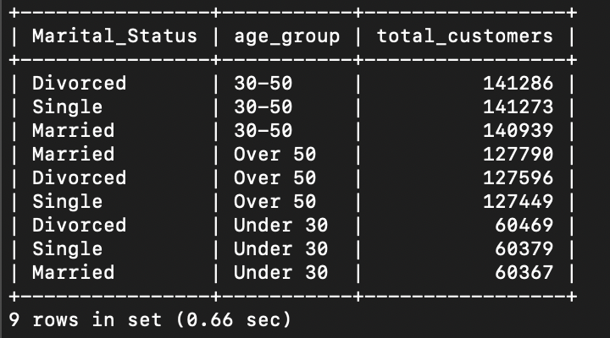

- Default rate by Employment Status
SELECT
Employment_Status,
COUNT(*) AS total_applicants,
SUM(Defaulted) AS total_defaults,
ROUND(SUM(Defaulted) * 100.0 / COUNT(*), 2) AS default_rate_percent
FROM loan_applications
GROUP BY Employment_Status
ORDER BY default_rate_percent DESC;
